080419Android Sticky Scheduler
Use Case Specification

Submitted to:

Asst. Prof. Ma. Rowena C. Solamo
Faculty Member
Department of Computer Science
College of Engineering
University of the Philippines, Diliman

Submitted by:
Buera, Louie
Cabiles, Miguel
Palaganas, Genesis Ian

In partial fulfillment of academic requirements
for the course
CS 191 Software Engineering I
of the
1st Semester, AY 2014-2015
Revision Control

History Revision:
Revision Date | Person Responsible | Version  Number | Modification
10/03/14 | Louie Buera | 1.0 | Initial Document; Version number should match the one found in the footer.

Use-Case Name: [Name of Use Case: eg. 1.0 Maintain Curriculum]

Description: [Write the 3 to 5 sentences that describes the Use Case.]

Preconditions: [If there are any, write the preconditions. Otherwise, simply type NONE.]

Flow of Events:
Scenario Name | Description
Scenario 1 (Basic Flow)  Athlete submits complete information to the system. | [Enumerate here the steps of the basic flow.]
Scenario 2  Athlete has no guardian information | [Enumerate here the steps of the basic flow.]

Activity Diagram of the Flow of Events:
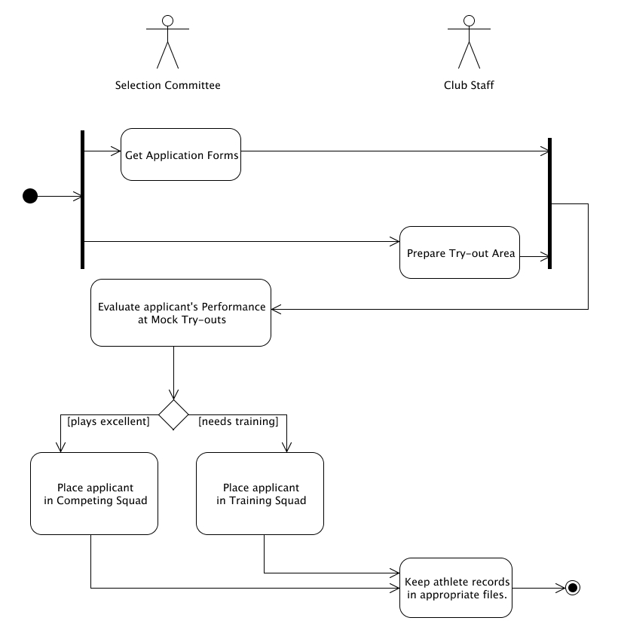

Place here the activity diagram. Make sure that the diagram is grouped as one and text does not wrap around the diagram.

Postcondition: [If there are any, write them here. Otherwise, type in NONE.]

Relationships: [If there are any, write them here. Otherwise, type in NONE.]

Special Requirements:
[If there are any, write them here. Otherwise, type in NONE.]

